
COMP1786
Mobile Application Design and Development

Student’s Name: Vu Thanh Nguyen
Student’s ID: 001343200
Submission Date: 04/12/2025

1. Brief statement of features you have implemented
Feature | Status | Your Comments
Functionality A | Fully completed ☒  Partially completed ☐  Having bugs/Not working ☐  Not implemented ☐
Functionality B | Fully completed ☒  Partially completed ☐  Having bugs/Not working ☐  Not implemented ☐
Functionality C | Fully completed ☒  Partially completed ☐  Having bugs/Not working ☐  Not implemented ☐
Functionality D | Fully completed ☒  Partially completed ☐  Having bugs/Not working ☐  Not implemented ☐
Functionality E | Fully completed ☒  Partially completed ☐  Having bugs/Not working ☐  Not implemented ☐
Functionality F | Fully completed ☒  Partially completed ☐  Having bugs/Not working ☐  Not implemented ☐
Functionality G | Fully completed ☐  Partially completed ☒  Having bugs/Not working ☐  Not implemented ☐

Link to recorded video (if you record your application before submitting the report)
The recorded video will demonstrate the implemented product. It is roughly 15 minutes. Enter the link into the below box
https://drive.google.com/drive/u/0/folders/1TsGf7-CtqCiGaQGBu7MTGclS4MLbIEuc

2. SCREEN SHOTS/DESIGN
In this section, the application is designed with the main color tones of blue and white, with convenient button arrangement for new and future users.

A. JavaCode
1. activity_main.xml (menu screen)
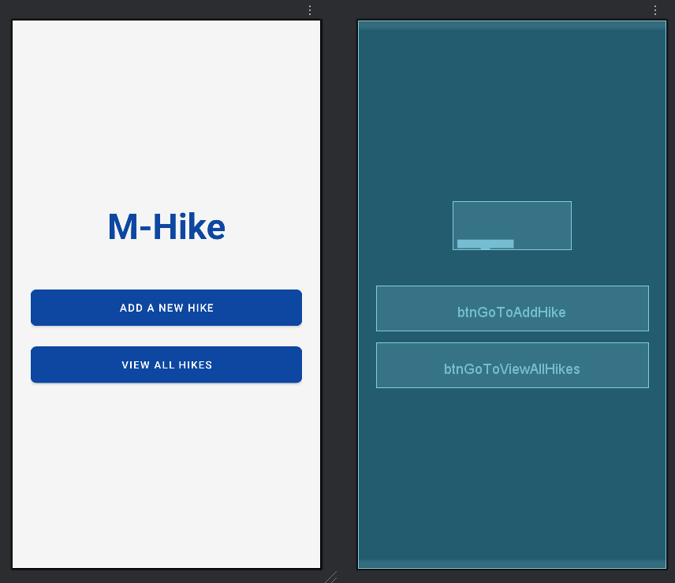
Figure 1: Design of menu screen
This layout uses a LinearLayout as its main container, with its child elements arranged vertically. The android:gravity="center" attribute ensures that all the elements within it are centered on the screen.At the top, a TextView displays the title "M-Hike" in a large, bold font for emphasis. Below the title are two MaterialButtons: the first with the text "ADD A NEW HIKE" and the second with "VIEW ALL HIKES".Both buttons are styled consistently, spanning the full width of the screen and featuring rounded corners. Margins (marginBottom) are used to create appropriate separation between the title and the buttons, while the padding attribute on the LinearLayout creates an empty border around the entire interface.

2. activity_add_hike.xml
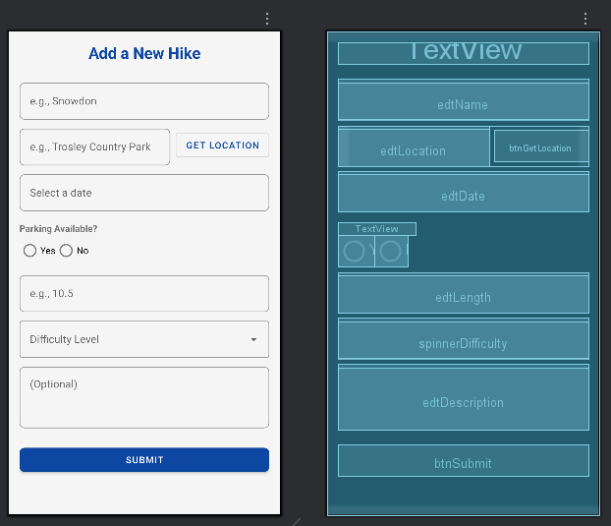
Figure 2: Form add hike screen
This layout is designed as a scrollable form for adding a new hike, wrapped in a ScrollView to ensure it's accessible on any screen size. Inside, a LinearLayout arranges all the fields vertically.The form begins with a centered "Add a New Hike" title and is followed by a series of input fields styled using Material Design's TextInputLayout for a modern and user-friendly interface. At the end of the form is a "Submit" button for the user to save the entered information.Here are the input fields on the form:
- Hike Name: A text input field for the name of the hike.
- Location: A text input field for the location, accompanied by a "Get Location" button.
- Date: A non-editable text field that is intended to open a date picker when clicked.
- Parking: A RadioGroup allowing the user to select either "Yes" or "No".
- Length: A numerical input field for the hike's length.
- Difficulty: A dropdown menu (AutoCompleteTextView) for selecting a difficulty level.
- Description: A multi-line text input field for a more detailed description of the hike.

3. hike_list_item.xml
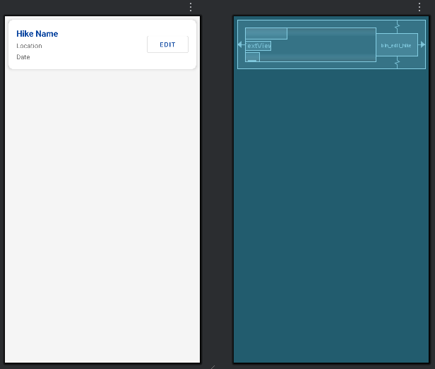
Figure 3: List hike screen
The hike_list_item.xml file defines the layout for a single hiking entry in a RecyclerView. The item is wrapped in a MaterialCardView, giving it a clean, modern look with rounded corners and subtle elevation. Inside, a RelativeLayout arranges elements efficiently. On the left, a vertical LinearLayout displays the hike’s name, location, and date. The name is bold and larger to make it stand out, while the location and date appear below as supporting details. On the right side, an outlined MaterialButton serves as the “Edit” button, aligned to the end and centered vertically for easy access.

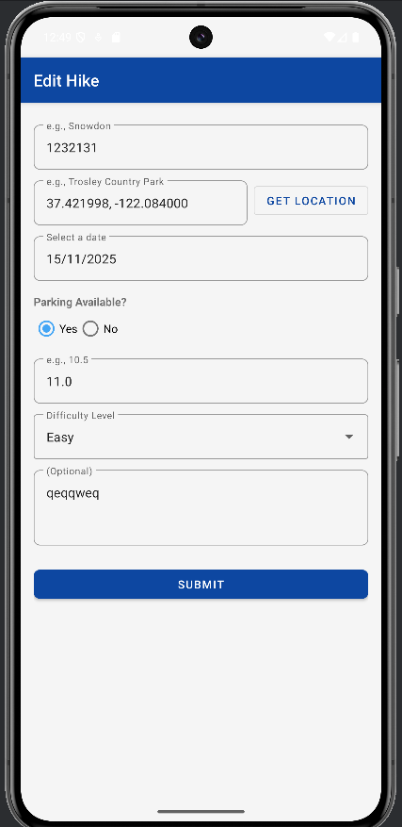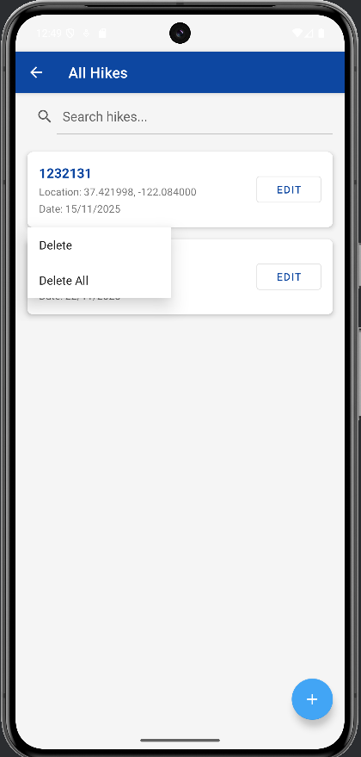
Figure 4: Edit screen and delete hike screen
When you click edit, the same information will appear as when you added it and the old information you entered will appear so you can easily change it when you want to edit it and click submit to close the form and change the information you want successfully.

Besides tapping to edit, the list supports long-press actions. When the user presses and holds an item, the app can show options such as Delete for removing that specific hike or Delete All to clear the entire list. This interaction keeps the layout simple while providing powerful management options.

4. activity_hike_list.xml
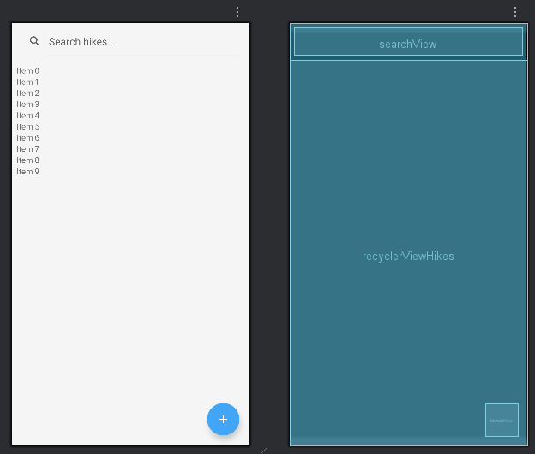
Figure 5: View list item screen
This layout defines the main interface of HikeListActivity. The screen is wrapped in a CoordinatorLayout, providing a flexible structure for modern UI behavior. Inside it, a vertical LinearLayout organizes the main components. At the top, a SearchView allows users to search for hikes using keywords. It is expanded by default and includes margins for a clean and accessible look. Below it, a RecyclerView displays the list of hikes in a smooth, scrollable format, with padding to ensure each item appears clear and spacious.
In the bottom-right corner, a FloatingActionButton with a plus icon is positioned for adding new hikes. Its floating style makes it easy to notice and quick to access. Overall, the interface is clean, intuitive, and optimized for managing and browsing hiking entries.

5. activity_hike_detail.xml
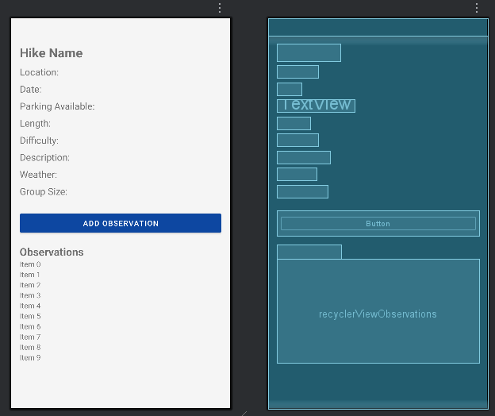
Figure 6: View information detail screen
This layout represents the Hike Detail screen. The entire interface is placed inside a ScrollView, allowing the content to scroll when it becomes long. Inside it, a vertical LinearLayout holds all the detailed information about the hike.
The top section includes several TextViews displaying key details such as the hike name, location, date, parking availability, length, difficulty, description, weather, and group size. Each piece of information is presented clearly with large text sizes and proper spacing, making it easy for users to read.
Below the details, there is an “Add Observation” button that lets users add new notes or observations related to the hike. At the bottom, a bold “Observations” label and a RecyclerView display the list of added observations.
The overall layout is clean, well-organized, and designed to provide a complete, easy-to-read overview of the hike’s details.

6. observation_list_item.xml
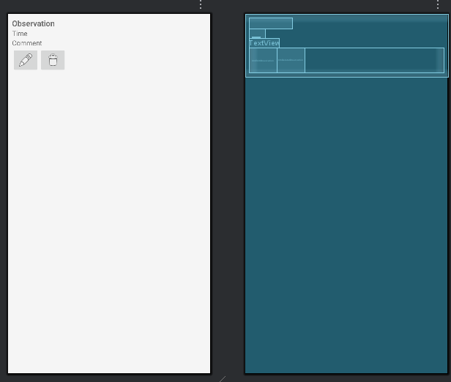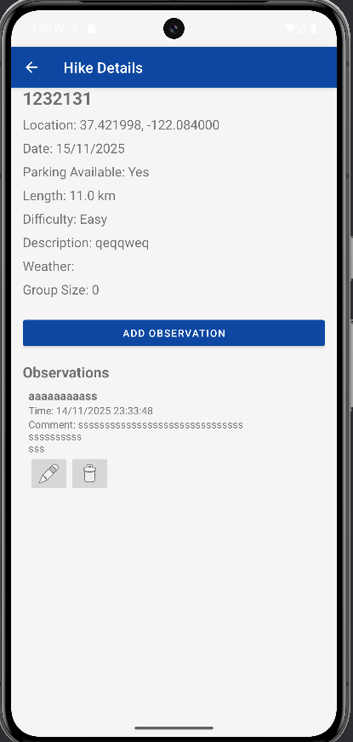
Figure 7: List observation layout screen
This XML defines the layout for a single observation item, typically used in a RecyclerView. The main vertical LinearLayout wraps the entire item with 8dp padding, keeping the content organized and readable. At the top, a TextView displays the observation title in bold with a 16sp font to make it stand out. Below it, another TextView shows the time the observation was added, followed by a TextView for the comment or details of the observation. At the bottom, a horizontal LinearLayout contains two ImageButtons: one for editing the observation using a standard edit icon, and one for deleting it using a trash icon. Overall, the layout presents information clearly at the top with action buttons at the bottom, creating an intuitive and user-friendly interface for managing observations.

7. activity_add_observation.xml
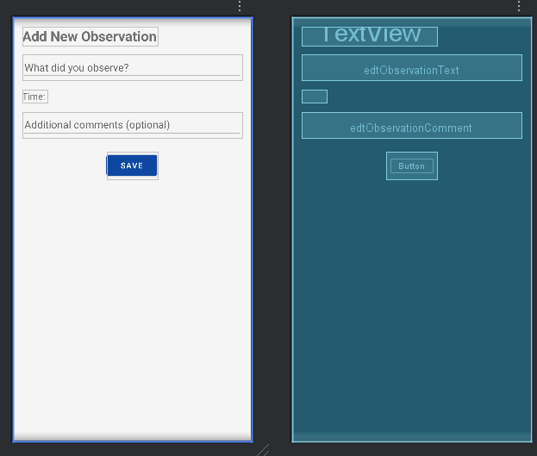
Figure 8: Add observation screen
This layout defines the Add New Observation screen. It is contained within a vertical LinearLayout with 16dp padding, keeping the components organized and easy to interact with. At the top, a TextView displays the title “Add New Observation” in bold with a 24sp font, making it immediately noticeable. Next is an EditText (edtObservationText) where users can enter the observation content, with a hint “What did you observe?”. Below it, a TextView (txtObservationTime) shows the current time, indicating when the observation is recorded. Another EditText (edtObservationComment) allows users to add optional additional comments, with proper spacing from the other fields.
At the bottom, a Save button (btnSaveObservation) is centered horizontally, allowing users to save the new observation. Overall, the layout is clean, simple, and user-friendly, making it easy to input and save observation data efficiently.

8. activity_edit_observation.xml
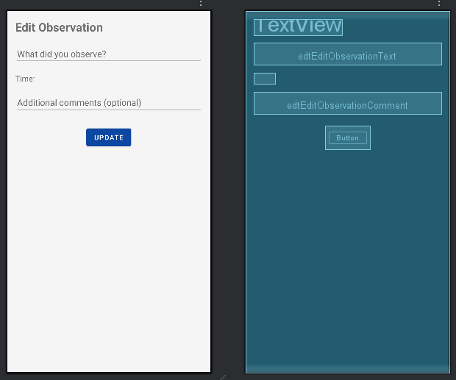
Figure 9: Edit observation screen
Similar to the interface of the add section, in this edit section, when users want to edit, they can still see the information fields they previously entered to change as they want. When editing successfully, the new information will be updated in the observation list outside.

B. FlutterCode

3. REFLECTION
The development of the M-Hike application was a foundational journey into native Android development, centered around core principles of data management and user interface design. The process involved creating a multi-screen application capable of performing essential CRUD (Create, Read, Update, Delete) operations, backed by a local SQLite database.
What Went Well
- The project established a clear and logical application flow.
- Separation of concerns was well-executed, with distinct Activities for each primary function:
  - Main menu
  - Form for adding/editing hikes
  - List view for all hikes
  - Detail view managing related observations
- Use of RecyclerView with custom adapters (HikeAdapter, ObservationAdapter) efficiently displayed dynamic lists.
- Encapsulation of all database logic within a single DatabaseHelper class ensured a clean separation between data and UI layers, making the codebase easier to navigate and debug.
- Implementation of Material Design components, such as MaterialCardView and TextInputLayout, contributed to a polished and modern user interface, providing a good user experience.
Lessons Learned
- Proper configuration of AndroidManifest.xml is crucial. An early issue where the "edit observation" screen failed to launch was due to forgetting to declare EditObservationActivity. Even perfectly written Java code will fail if core configuration is incomplete.
- Understanding the Android Activity lifecycle is important. Correct use of methods like onResume to refresh lists after returning from edit/add screens ensured the UI reflected the current state of the database.
- Implementing features like location access highlighted the need for handling runtime permissions, respecting user privacy in modern Android development.
What Could Have Been Improved and How
While functional, the application's architecture could be significantly enhanced. Currently, Activities handle UI logic, data loading, and user input, which places a heavy burden on them. Improvements include:
- Introduce a ViewModel (MVVM Architecture)
  - Move all data-related logic and state out of Activities.
  - Activities would only observe data changes (via LiveData or Flow) and update the UI.
  - Solves issues with data loss during configuration changes (e.g., screen rotation).
- Migrate to Room
  - Manual implementation of SQLiteOpenHelper is error-prone and requires boilerplate code.
  - Room provides compile-time verification of SQL queries, simplifies database setup, and integrates seamlessly with ViewModel and LiveData.
  - Makes the data access layer more robust and concise.
- Use Coroutines for Background Threads
  - Currently, database operations are performed on the main UI thread, which can freeze the app for larger datasets.
  - Moving database calls to a background thread via Kotlin Coroutines simplifies asynchronous programming and keeps the app responsive.

4. EVALUATION

The M-Hike application serves as a digital logbook for outdoor enthusiasts, allowing them to record, manage, and review their hiking excursions. Developed as a native Android application, it provides core functionality for creating, reading, updating, and deleting hike details and associated observations, all stored locally on the user's device.
This evaluation critically analyzes the application based on several key software development aspects, including human-computer interaction (HCI), security, adaptability to screen sizes, and necessary changes for production deployment. Each point is justified with specific examples from the application's source code and design.

1. Human-Computer Interaction (HCI)
Human-computer interaction focuses on the design and use of computer technology, specifically the interface between users and computers. A successful application must be intuitive, efficient, and satisfying to use. The M-Hike app demonstrates a solid understanding of fundamental HCI principles.
Strengths and Justification
- Simplicity and clarity: The main screen (activity_main.xml) presents two clear actions: "ADD A NEW HIKE" and "VIEW ALL HIKES", reducing cognitive load.
- Predictable navigation: Linear flow from hike list (HikeListActivity) → detail view (HikeDetailActivity) → add/edit related data (AddObservationActivity, EditObservationActivity). The Up button in the ActionBar ensures users can return to previous screens.
- Feedback mechanisms:
  - Toast messages confirm successful actions, e.g., "Hike saved successfully!".
  - TextInputLayout provides inline validation errors, e.g., "Name is required."
  - AlertDialogs prevent accidental deletion, following Jakob Nielsen’s heuristic of error prevention.
- Consistent UI design: Uses Material Design components:
  - MaterialCardView for organized lists (hike_list_item.xml)
  - MaterialButton for consistent interactive elements
  - DatePickerDialog for date selection and AutoCompleteTextView for difficulty level selection
2. Security
Security is essential to protect user data and maintain trust. As an offline application, M-Hike has minimal security, but existing vulnerabilities exist.
Current State and Justification
- Unencrypted local storage: The SQLite database managed by DatabaseHelper is stored in plain text. On rooted or compromised devices, data (including location) can be easily extracted.
- Client-side validation only: Checks for empty strings, but this does not prevent malicious input if connected to a backend.
- Positive practice: Correct handling of runtime permissions for location access (FusedLocationProviderClient with ACCESS_FINE_LOCATION), respecting user consent and privacy.
3. Ability of the App to Run on a Range of Screen Sizes
Android apps must work consistently across various devices, screen sizes, and orientations.
Strengths
- ScrollView in activity_add_hike.xml ensures users can access all fields on small screens.
- Layouts use match_parent and wrap_content for flexible sizing.
- Consistent use of dp for layout and sp for text ensures proportional scaling across screen densities.
Limitations and Improvements
- Layouts are mostly single-pane, portrait-oriented:
  - Landscape mode: buttons take up too much vertical space
  - Tablets: single-column list/detail views appear stretched
- Recommended improvements:
  - Create alternative layouts (layout-land, layout-sw600dp)
  - Use ConstraintLayout for a more flexible and performant view hierarchy
  - Implement master-detail layouts for larger screens
4. Changes Needed for Live Use
Transitioning M-Hike to a production-ready app requires substantial architectural and feature enhancements:
- Backend and cloud synchronization:
  - Users expect persistent, secure data across devices
  - Implement a backend (Node.js, Python, or Firebase) with cloud database (Firestore, PostgreSQL)
  - Refactor app for authentication, network requests, and data sync between SQLite and cloud
- Security improvements:
  - Robust authentication (OAuth 2.0, Firebase Auth)
  - HTTPS for all communication
  - Encrypt local database (SQLCipher)
- Architecture overhaul:
  - Adopt MVVM: Activities observe data via ViewModel, improving scalability and handling configuration changes
  - Migrate from SQLiteOpenHelper to Room for safer, concise database management
  - Move database/network operations to background threads using Kotlin Coroutines
- Error handling and analytics:
  - Integrate Firebase Crashlytics for bug monitoring
  - Integrate Firebase Analytics for user engagement insights
5. Other Considerations (Testing and Accessibility)
- Testing: Currently lacks automated testing
  - Implement Unit Tests (JUnit) for ViewModel/business logic
  - Implement Instrumentation Tests (Espresso) for UI behavior and user flows
- Accessibility (a11y):
  - Ensure touch targets ≥48dp
  - Provide content descriptions for images/buttons
  - Verify color contrast ratios meet WCAG standards

5. CODE DESCRIPTION
1.MainActivity.java
public class MainActivity extends AppCompatActivity {
@Override
protected void onCreate(Bundle savedInstanceState) {
super.onCreate(savedInstanceState);
EdgeToEdge.enable(this);
setContentView(R.layout.activity_main);
ViewCompat.setOnApplyWindowInsetsListener(findViewById(R.id.main), (v, insets) -> {
Insets systemBars = insets.getInsets(WindowInsetsCompat.Type.systemBars());
v.setPadding(systemBars.left, systemBars.top, systemBars.right, systemBars.bottom);
return insets;
});
Button btnGoToAddHike = findViewById(R.id.btnGoToAddHike);
Button btnGoToViewAllHikes = findViewById(R.id.btnGoToViewAllHikes);
btnGoToAddHike.setOnClickListener(v -> {
Intent intent = new Intent(MainActivity.this, AddHikeActivity.class);
startActivity(intent);
});
btnGoToViewAllHikes.setOnClickListener(v -> {
Intent intent = new Intent(MainActivity.this, HikeListActivity.class);
startActivity(intent);
});
}
}

This code sets up the main screen of the application. In the onCreate method, it displays the user interface defined in the activity_main.xml file. It then finds two buttons and assigns click listeners to them. When the "Go To Add Hike" button is pressed, the app navigates to the AddHikeActivity screen. When the "Go To View All Hikes" button is pressed, the app opens the HikeListActivity screen.
This part of the code enables "edge-to-edge" mode, allowing the app's UI to draw under the system bars for a more modern and immersive look.
1. EdgeToEdge.enable(this);: This line enables the edge-to-edge feature.
2. ViewCompat.setOnApplyWindowInsetsListener(...): This code listens for the dimensions of the system bars (like the status bar at the top and the navigation bar at the bottom), which are called "insets".
3. v.setPadding(...): Based on the size of those insets, it adds padding to the main layout. This prevents your content from being hidden behind the system bars, ensuring the UI is both beautiful and functional.

2.AddHikeActivity.java
public class AddHikeActivity extends AppCompatActivity {
public static final String EXTRA_HIKE_ID = "com.example.myapplication.EXTRA_HIKE_ID";
private static final int LOCATION_PERMISSION_REQUEST_CODE = 1;
private TextInputEditText edtName, edtLocation, edtDate, edtLength, edtDescription;
private TextInputLayout nameLayout, locationLayout, dateLayout, lengthLayout;
private AutoCompleteTextView spinnerDifficulty;
private RadioGroup radioParking;
private Button btnSubmit, btnGetLocation;
private TextView txtFormTitle;
private DatabaseHelper databaseHelper;
private int hikeId = -1;
private FusedLocationProviderClient fusedLocationClient;
@Override
protected void onCreate(Bundle savedInstanceState) {
super.onCreate(savedInstanceState);
setContentView(R.layout.activity_add_hike);
databaseHelper = new DatabaseHelper(this);
fusedLocationClient = LocationServices.getFusedLocationProviderClient(this);
setupViews();
setupDifficultyDropdown();
setupListeners();
if (getIntent().hasExtra(EXTRA_HIKE_ID)) {
hikeId = getIntent().getIntExtra(EXTRA_HIKE_ID, -1);
if (hikeId != -1) {
setTitle(R.string.form_title_edit_hike);
txtFormTitle.setText(R.string.form_title_edit_hike);
loadHikeData();
} else {
setTitle(R.string.form_title_add_hike);
txtFormTitle.setText(R.string.form_title_add_hike);
}
} else {
setTitle(R.string.form_title_add_hike);
txtFormTitle.setText(R.string.form_title_add_hike);
}
}
private void loadHikeData() {
Hike hike = databaseHelper.getHikeById(hikeId);
if (hike != null) {
edtName.setText(hike.getName());
edtLocation.setText(hike.getLocation());
edtDate.setText(hike.getDate());
edtLength.setText(String.valueOf(hike.getLength()));
if (hike.getParkingAvailable() == 1) {
radioParking.check(R.id.rdoYes);
} else {
radioParking.check(R.id.rdoNo);
}
spinnerDifficulty.setText(hike.getDifficulty(), false);
edtDescription.setText(hike.getDescription());
}
}
private void setupViews() {
txtFormTitle = findViewById(R.id.txtFormTitle);
nameLayout = findViewById(R.id.name_layout);
locationLayout = findViewById(R.id.location_layout);
dateLayout = findViewById(R.id.date_layout);
lengthLayout = findViewById(R.id.length_layout);
edtName = findViewById(R.id.edtName);
edtLocation = findViewById(R.id.edtLocation);
edtDate = findViewById(R.id.edtDate);
edtLength = findViewById(R.id.edtLength);
radioParking = findViewById(R.id.radioParking);
spinnerDifficulty = findViewById(R.id.spinnerDifficulty);
edtDescription = findViewById(R.id.edtDescription);
btnSubmit = findViewById(R.id.btnSubmit);
btnGetLocation = findViewById(R.id.btnGetLocation);
}
private void setupDifficultyDropdown() {
String[] difficultyLevels = getResources().getStringArray(R.array.difficulty_levels);
ArrayAdapter<String> adapter = new ArrayAdapter<>(this, android.R.layout.simple_dropdown_item_1line, difficultyLevels);
spinnerDifficulty.setAdapter(adapter);
}
private void setupListeners() {
edtDate.setOnClickListener(v -> showDatePickerDialog());
btnSubmit.setOnClickListener(v -> {
if (validateInputs()) {
showConfirmationDialog();
}
});
btnGetLocation.setOnClickListener(v -> getCurrentLocation());
}
private void getCurrentLocation() {
if (ActivityCompat.checkSelfPermission(this, Manifest.permission.ACCESS_FINE_LOCATION) != PackageManager.PERMISSION_GRANTED && ActivityCompat.checkSelfPermission(this, Manifest.permission.ACCESS_COARSE_LOCATION) != PackageManager.PERMISSION_GRANTED) {
ActivityCompat.requestPermissions(this, new String[]{Manifest.permission.ACCESS_FINE_LOCATION}, LOCATION_PERMISSION_REQUEST_CODE);
return;
}
fusedLocationClient.getLastLocation()
.addOnSuccessListener(this, location -> {
if (location != null) {
edtLocation.setText(String.format(Locale.getDefault(), "%f, %f", location.getLatitude(), location.getLongitude()));
} else {
Toast.makeText(this, "Unable to get location.", Toast.LENGTH_SHORT).show();
}
});
}
@Override
public void onRequestPermissionsResult(int requestCode, @NonNull String[] permissions, @NonNull int[] grantResults) {
super.onRequestPermissionsResult(requestCode, permissions, grantResults);
if (requestCode == LOCATION_PERMISSION_REQUEST_CODE) {
if (grantResults.length > 0 && grantResults[0] == PackageManager.PERMISSION_GRANTED) {
getCurrentLocation();
} else {
Toast.makeText(this, "Location permission denied.", Toast.LENGTH_SHORT).show();
}
}
}
private boolean validateInputs() {
nameLayout.setError(null);
locationLayout.setError(null);
dateLayout.setError(null);
lengthLayout.setError(null);
String name = edtName.getText().toString().trim();
String location = edtLocation.getText().toString().trim();
String date = edtDate.getText().toString().trim();
String length = edtLength.getText().toString().trim();
if (TextUtils.isEmpty(name)) {
nameLayout.setError("Name is required.");
return false;
}
if (TextUtils.isEmpty(location)) {
locationLayout.setError("Location is required.");
return false;
}
if (TextUtils.isEmpty(date)) {
dateLayout.setError("Date is required.");
return false;
}
if (radioParking.getCheckedRadioButtonId() == -1) {
Toast.makeText(this, "Please select a parking option.", Toast.LENGTH_SHORT).show();
return false;
}
if (TextUtils.isEmpty(length)) {
lengthLayout.setError("Length is required.");
return false;
}
return true;
}
private void showConfirmationDialog() {
String name = edtName.getText().toString().trim();
String location = edtLocation.getText().toString().trim();
String date = edtDate.getText().toString().trim();
String lengthStr = edtLength.getText().toString().trim();
String difficulty = spinnerDifficulty.getText().toString();
String description = edtDescription.getText().toString().trim();
boolean parkingAvailable = radioParking.getCheckedRadioButtonId() == R.id.rdoYes;
String parking = parkingAvailable ? "Yes" : "No";
String confirmationMessage = "Please confirm the details:\n\n" +
"Name: " + name + "\n" +
"Location: " + location + "\n" +
"Date: " + date + "\n" +
"Parking: " + parking + "\n" +
"Length: " + lengthStr + " km\n" +
"Difficulty: " + difficulty + "\n" +
"Description: " + (!description.isEmpty() ? description : "N/A");
new AlertDialog.Builder(this)
.setTitle("Confirm Hike Details")
.setMessage(confirmationMessage)
.setPositiveButton("Confirm", (dialog, which) -> {
saveHikeAndNavigate();
})
.setNegativeButton("Go Back", (dialog, which) -> {
dialog.dismiss();
})
.create()
.show();
}
private void saveHikeAndNavigate() {
String name = edtName.getText().toString().trim();
String location = edtLocation.getText().toString().trim();
String date = edtDate.getText().toString().trim();
double length = Double.parseDouble(edtLength.getText().toString().trim());
int parking = radioParking.getCheckedRadioButtonId() == R.id.rdoYes ? 1 : 0;
String difficulty = spinnerDifficulty.getText().toString();
String description = edtDescription.getText().toString().trim();
String weather = ""; // Not in layout
int groupSize = 0; // Not in layout
if (hikeId == -1) {
databaseHelper.addHike(name, location, date, parking, length, difficulty, description, weather, groupSize);
Toast.makeText(this, "Hike saved successfully!", Toast.LENGTH_SHORT).show();
} else {
databaseHelper.updateHike(hikeId, name, location, date, parking, length, difficulty, description, weather, groupSize);
Toast.makeText(this, "Hike updated successfully!", Toast.LENGTH_SHORT).show();
}
Intent intent = new Intent(AddHikeActivity.this, HikeListActivity.class);
intent.addFlags(Intent.FLAG_ACTIVITY_CLEAR_TOP | Intent.FLAG_ACTIVITY_NEW_TASK);
startActivity(intent);
finish();
}
private void showDatePickerDialog() {
final Calendar calendar = Calendar.getInstance();
int year = calendar.get(Calendar.YEAR);
int month = calendar.get(Calendar.MONTH);
int day = calendar.get(Calendar.DAY_OF_MONTH);
new DatePickerDialog(this,
(view, year1, monthOfYear, dayOfMonth) -> {
Calendar newDate = Calendar.getInstance();
newDate.set(year1, monthOfYear, dayOfMonth);
SimpleDateFormat sdf = new SimpleDateFormat("dd/MM/yyyy", Locale.getDefault());
edtDate.setText(sdf.format(newDate.getTime()));
}, year, month, day).show();
}
}
This code manages the "Add/Edit Hike" screen. It functions as a form where users can input details about a hike, such as its name, location, date, and difficulty. The screen has two modes: "Add" for creating a new hike, and "Edit" for modifying an existing one, which is determined by whether a hike ID is passed to it from the previous screen. After the user fills out the form, the code validates the inputs, shows a confirmation dialog, and then saves or updates the hike information in a local database.
The most complex part of this code is the location-fetching functionality. It allows the user to automatically fill in the hike's location using the device's GPS.
1. Initializing the FusedLocationProviderClient
- In the onCreate() method, you create the client:
fusedLocationClient = LocationServices.getFusedLocationProviderClient(this);
- This is the modern Google Play Services API for retrieving the device’s location.
- It provides better accuracy and battery optimization compared to older Android location APIs.

2. Permission Check and Request
- When the user taps the Get Location button, the getCurrentLocation() method is executed.
- ActivityCompat.checkSelfPermission(...) checks if the app already has the ACCESS_FINE_LOCATION permission.
- If the app does not have permission:
ActivityCompat.requestPermissions(...)
→ The system shows a permission dialog.
- LOCATION_PERMISSION_REQUEST_CODE is used to identify the permission request when handling the result.
3. Handling the Permission Request Result
- The system automatically calls onRequestPermissionsResult() after the user selects Allow or Deny.
- Inside this method:
  - You verify the correct requestCode.
  - You check whether the permission was actually granted.
- If the permission was granted, getCurrentLocation() is called again to continue retrieving the location.
- If the permission was denied, a Toast message notifies the user.
4. Fetching the Device Location
- Once the app has permission, it calls:
fusedLocationClient.getLastLocation()
- This is an asynchronous operation that retrieves the device’s last known location.
- .addOnSuccessListener(...) runs only when the location is successfully returned.
- If location != null:
  - Extract latitude and longitude.
  - Display them in the UI.
- If location == null:
→ This may happen if GPS is off, or the device has never recorded a location → show a message to the user.

3. HikeListActivity.java
public class HikeListActivity extends AppCompatActivity {
private RecyclerView recyclerViewHikes;
private HikeAdapter hikeAdapter;
private List<Hike> hikeList;
private DatabaseHelper databaseHelper;
private SearchView searchView;
@Override
protected void onCreate(Bundle savedInstanceState) {
super.onCreate(savedInstanceState);
setContentView(R.layout.activity_hike_list);
if (getSupportActionBar() != null) {
getSupportActionBar().setDisplayHomeAsUpEnabled(true);
getSupportActionBar().setTitle("All Hikes");
}
databaseHelper = new DatabaseHelper(this);
recyclerViewHikes = findViewById(R.id.recyclerViewHikes);
recyclerViewHikes.setLayoutManager(new LinearLayoutManager(this));
hikeList = new ArrayList<>();
hikeAdapter = new HikeAdapter(this, hikeList); // Pass context here
recyclerViewHikes.setAdapter(hikeAdapter);
searchView = findViewById(R.id.searchView);
searchView.setOnQueryTextListener(new SearchView.OnQueryTextListener() {
@Override
public boolean onQueryTextSubmit(String query) {
searchHikes(query);
return true;
}
@Override
public boolean onQueryTextChange(String newText) {
searchHikes(newText);
return true;
}
});
FloatingActionButton fabAddHike = findViewById(R.id.fabAddHike);
fabAddHike.setOnClickListener(v -> {
Intent intent = new Intent(HikeListActivity.this, AddHikeActivity.class);
startActivity(intent);
});
}
@Override
protected void onResume() {
super.onResume();
loadHikesFromDatabase();
}
private void loadHikesFromDatabase() {
// If search view is not empty, maintain the search results
if (searchView != null && !searchView.getQuery().toString().isEmpty()) {
searchHikes(searchView.getQuery().toString());
} else {
List<Hike> updatedHikeList = databaseHelper.getAllHikes();
hikeAdapter.updateData(updatedHikeList);
}
}
private void searchHikes(String query) {
List<Hike> searchResults;
if (query.isEmpty()) {
searchResults = databaseHelper.getAllHikes();
} else {
searchResults = databaseHelper.searchHikes(query);
}
hikeAdapter.updateData(searchResults);
}
@Override
public boolean onSupportNavigateUp() {
finish();
return true;
}
}

This code manages the "Hike List" screen. Its main function is to display all the hikes that have been saved in the database. The screen uses a RecyclerView to display the list efficiently. It also includes a SearchView that allows the user to filter the list by name, and a Floating Action Button to open the "Add Hike" screen. The list automatically refreshes each time the user returns to this screen, ensuring the data is always up-to-date.
The core and most notable part of this screen is the combination of the RecyclerView, SearchView, and DatabaseHelper to create a searchable, self-updating list.
1. RecyclerView Setup:
- A RecyclerView is an advanced UI component for displaying long lists. It works efficiently by recycling the item views that have scrolled off-screen.
- hikeAdapter = new HikeAdapter(...): The HikeAdapter is a custom class (not present in this file) that acts as a bridge. It receives the data (hikeList) and "knows" how to create the layout for each row in the list and fill it with data.
- recyclerViewHikes.setAdapter(hikeAdapter): This attaches the adapter to the RecyclerView to begin displaying the data.
2. SearchView Integration:
- searchView.setOnQueryTextListener(...): A listener is assigned to the search field.
- onQueryTextChange(String newText): This method is called every time the user types or deletes a character. It immediately calls searchHikes(newText) to update the list in real-time.
- searchHikes(String query): This method queries the database (databaseHelper.searchHikes(query)) to get the list of matching results and then calls hikeAdapter.updateData(...) to request that the adapter refresh the UI with the new data.
3. Automatic Refresh in onResume():
- The onResume() method is part of the Activity lifecycle, called every time the screen becomes visible again (for instance, after adding/editing a hike and navigating back).
- By calling loadHikesFromDatabase() here, you ensure the list always shows the most current data without requiring the user to manually refresh.
- The logic inside loadHikesFromDatabase is smart: it checks if the user is currently searching for something. If so, it preserves the search results; otherwise, it reloads the entire list. This helps maintain the user's state.

4. Hike.java
public class Hike {
private int id;
private String name;
private String location;
private String date;
private int parkingAvailable;
private double length;
private String difficulty;
private String description;
private String weather;
private int groupSize;
// Constructor
public Hike(int id, String name, String location, String date, int parkingAvailable, double length, String difficulty, String description, String weather, int groupSize) {
this.id = id;
this.name = name;
this.location = location;
this.date = date;
this.parkingAvailable = parkingAvailable;
this.length = length;
this.difficulty = difficulty;
this.description = description;
this.weather = weather;
this.groupSize = groupSize;
}
// Getters and Setters
public int getId() {
return id;
}
public void setId(int id) {
this.id = id;
}
public String getName() {
return name;
}
public void setName(String name) {
this.name = name;
}
public String getLocation() {
return location;
}
public void setLocation(String location) {
this.location = location;
}
public String getDate() {
return date;
}
public void setDate(String date) {
this.date = date;
}
public int getParkingAvailable() {
return parkingAvailable;
}
public void setParkingAvailable(int parkingAvailable) {
this.parkingAvailable = parkingAvailable;
}
public double getLength() {
return length;
}
public void setLength(double length) {
this.length = length;
}
public String getDifficulty() {
return difficulty;
}
public void setDifficulty(String difficulty) {
this.difficulty = difficulty;
}
public String getDescription() {
return description;
}
public void setDescription(String description) {
this.description = description;
}
public String getWeather() {
return weather;
}
public void setWeather(String weather) {
this.weather = weather;
}
public int getGroupSize() {
return groupSize;
}
public void setGroupSize(int groupSize) {
this.groupSize = groupSize;
}
}

1.Properties: These are the private variables at the top (like name, location, date). They are the basic pieces of information that define a hike.
2.Constructor: This is the public Hike(...) method. It's the way you create a new Hike object. When you call it, you must provide all the necessary information, and it will create a complete Hike object from that data.
3.Getters and Setters: These are the public methods like getName() and setName(). Other parts of your app (like your Activities) will use these methods to safely read (get) or change (set) the information of a Hike object.Essentially, this class is an organized way to bundle all the data for a single hike into one object, making it easier to pass that data between screens and save it to the database.

5. HikeDetailActivity.java
public class HikeDetailActivity extends AppCompatActivity implements ObservationAdapter.OnObservationListener {
public static final String EXTRA_HIKE_ID = "extra_hike_id";
private DatabaseHelper databaseHelper;
private Hike hike;
private int hikeId;
private TextView detailHikeName, detailHikeLocation, detailHikeDate, detailHikeParking, detailHikeLength, detailHikeDifficulty, detailHikeDescription, detailHikeWeather, detailHikeGroupSize;
private Button btnAddObservation;
private RecyclerView recyclerViewObservations;
private ObservationAdapter observationAdapter;
private List<Observation> observationList;
@Override
protected void onCreate(Bundle savedInstanceState) {
super.onCreate(savedInstanceState);
setContentView(R.layout.activity_hike_detail);
if (getSupportActionBar() != null) {
getSupportActionBar().setDisplayHomeAsUpEnabled(true);
getSupportActionBar().setTitle("Hike Details");
}
databaseHelper = new DatabaseHelper(this);
initViews();
hikeId = getIntent().getIntExtra(EXTRA_HIKE_ID, -1);
if (hikeId != -1) {
hike = databaseHelper.getHikeById(hikeId);
if (hike != null) {
populateHikeDetails();
setupObservationList();
setupListeners();
} else {
Toast.makeText(this, "Hike not found!", Toast.LENGTH_SHORT).show();
finish();
}
} else {
Toast.makeText(this, "Invalid Hike ID!", Toast.LENGTH_SHORT).show();
finish();
}
}
@Override
protected void onResume() {
super.onResume();
if (hikeId != -1) {
loadObservations();
}
}
private void initViews() {
detailHikeName = findViewById(R.id.detail_hike_name);
detailHikeLocation = findViewById(R.id.detail_hike_location);
detailHikeDate = findViewById(R.id.detail_hike_date);
detailHikeParking = findViewById(R.id.detail_hike_parking);
detailHikeLength = findViewById(R.id.detail_hike_length);
detailHikeDifficulty = findViewById(R.id.detail_hike_difficulty);
detailHikeDescription = findViewById(R.id.detail_hike_description);
detailHikeWeather = findViewById(R.id.detail_hike_weather);
detailHikeGroupSize = findViewById(R.id.detail_hike_group_size);
btnAddObservation = findViewById(R.id.btnAddObservation);
recyclerViewObservations = findViewById(R.id.recyclerViewObservations);
}
private void populateHikeDetails() {
detailHikeName.setText(hike.getName());
detailHikeLocation.setText("Location: " + hike.getLocation());
detailHikeDate.setText("Date: " + hike.getDate());
detailHikeParking.setText("Parking Available: " + (hike.getParkingAvailable() == 1 ? "Yes" : "No"));
detailHikeLength.setText("Length: " + hike.getLength() + " km");
detailHikeDifficulty.setText("Difficulty: " + hike.getDifficulty());
detailHikeDescription.setText("Description: " + hike.getDescription());
detailHikeWeather.setText("Weather: " + hike.getWeather());
detailHikeGroupSize.setText("Group Size: " + hike.getGroupSize());
}
private void setupObservationList() {
recyclerViewObservations.setLayoutManager(new LinearLayoutManager(this));
observationList = new ArrayList<>();
observationAdapter = new ObservationAdapter(this, observationList, this);
recyclerViewObservations.setAdapter(observationAdapter);
}
private void setupListeners() {
btnAddObservation.setOnClickListener(v -> {
Intent intent = new Intent(HikeDetailActivity.this, AddObservationActivity.class);
intent.putExtra(AddObservationActivity.EXTRA_HIKE_ID, hikeId);
startActivity(intent);
});
}
private void loadObservations() {
List<Observation> updatedList = databaseHelper.getObservationsForHike(hikeId);
observationAdapter.updateData(updatedList);
}
@Override
public void onDeleteClick(Observation observation) {
databaseHelper.deleteObservation(observation.getId());
Toast.makeText(this, "Observation deleted", Toast.LENGTH_SHORT).show();
loadObservations();
}
@Override
public void onEditClick(Observation observation) {
Intent intent = new Intent(this, EditObservationActivity.class);
intent.putExtra(EditObservationActivity.EXTRA_OBSERVATION_ID, observation.getId());
startActivity(intent);
}
@Override
public boolean onSupportNavigateUp() {
finish();
return true;
}
}

This code file manages the "Hike Detail Screen". Its main function is to display all the information for a specific hike selected from the list screen. It receives the hike's ID, uses that ID to query data from the database, and then populates the information fields like name, location, date, etc.Additionally, this screen displays a list of "Observations" recorded for that hike. The user can add, edit, or delete these observations directly from the detail screen.
The most notable part of the code here is how this Activity manages and interacts with the child list (the list of observations) through an Adapter and an Interface.
1.Loading Data:
- In onCreate, the Activity gets the hikeId passed from the previous screen.
- Based on the hikeId, it retrieves the hike's information (Hike object) and the corresponding list of observations (Observation list) from the DatabaseHelper.
2.Setting up the Observation List:
- setupObservationList() initializes the RecyclerView and ObservationAdapter.
- Crucially, when creating the adapter, it passes this (the Activity itself) to serve as an event listener (OnObservationListener ).
3.The Listener Pattern:
- HikeDetailActivity has the line implements ObservationAdapter.OnObservationListener. This means the Activity "promises" to handle click events that happen inside the ObservationAdapter.
- Inside the ObservationAdapter (a file not shown here), when a user clicks the "Edit" or "Delete" button on an observation item, the adapter doesn't handle it directly. Instead, it calls the onEditClick() or onDeleteClick() methods on the listener that was provided to it.
4. Since this Activity is that listener, the onEditClick and onDeleteClick methods at the end of the HikeDetailActivity file are the ones that get executed.
- On Delete: It calls databaseHelper.deleteObservation(...) and then reloads the list.
- On Edit: It opens the EditObservationActivity, passing the ID of the observation to be edited.

6. HikeAdapter.java
public class HikeAdapter extends RecyclerView.Adapter<HikeAdapter.HikeViewHolder> {
private List<Hike> hikeList;
private Context context;
private DatabaseHelper databaseHelper;
public HikeAdapter(Context context, List<Hike> hikeList) {
this.context = context;
this.hikeList = hikeList;
this.databaseHelper = new DatabaseHelper(context);
}
@NonNull
@Override
public HikeViewHolder onCreateViewHolder(@NonNull ViewGroup parent, int viewType) {
View view = LayoutInflater.from(parent.getContext()).inflate(R.layout.hike_list_item, parent, false);
return new HikeViewHolder(view);
}
@Override
public void onBindViewHolder(@NonNull HikeViewHolder holder, int position) {
Hike hike = hikeList.get(position);
holder.hikeName.setText(hike.getName());
holder.hikeLocation.setText("Location: " + hike.getLocation());
holder.hikeDate.setText("Date: " + hike.getDate());
holder.itemView.setOnClickListener(v -> {
Intent intent = new Intent(context, HikeDetailActivity.class);
intent.putExtra(HikeDetailActivity.EXTRA_HIKE_ID, hike.getId());
context.startActivity(intent);
});
holder.btnEdit.setOnClickListener(v -> {
Intent intent = new Intent(context, AddHikeActivity.class);
intent.putExtra(AddHikeActivity.EXTRA_HIKE_ID, hike.getId());
context.startActivity(intent);
});
holder.itemView.setOnLongClickListener(v -> {
PopupMenu popup = new PopupMenu(context, v);
popup.getMenuInflater().inflate(R.menu.hike_list_item_menu, popup.getMenu());
popup.setOnMenuItemClickListener(item -> {
int itemId = item.getItemId();
if (itemId == R.id.menu_delete) {
new AlertDialog.Builder(context)
.setTitle("Delete Hike")
.setMessage("Are you sure you want to delete this hike?")
.setPositiveButton(android.R.string.yes, (dialog, which) -> {
databaseHelper.deleteHike(hike.getId());
updateData(databaseHelper.getAllHikes());
})
.setNegativeButton(android.R.string.no, null)
.setIcon(android.R.drawable.ic_dialog_alert)
.show();
return true;
} else if (itemId == R.id.menu_delete_all) {
new AlertDialog.Builder(context)
.setTitle("Delete All Hikes")
.setMessage("Are you sure you want to delete all hikes?")
.setPositiveButton(android.R.string.yes, (dialog, which) -> {
databaseHelper.deleteAllHikes();
updateData(databaseHelper.getAllHikes());
})
.setNegativeButton(android.R.string.no, null)
.setIcon(android.R.drawable.ic_dialog_alert)
.show();
return true;
}
return false;
});
popup.show();
return true;
});
}
@Override
public int getItemCount() {
return hikeList.size();
}
public void updateData(List<Hike> newHikeList) {
this.hikeList.clear();
this.hikeList.addAll(newHikeList);
notifyDataSetChanged();
}
static class HikeViewHolder extends RecyclerView.ViewHolder {
TextView hikeName, hikeLocation, hikeDate;
Button btnEdit;
public HikeViewHolder(@NonNull View itemView) {
super(itemView);
hikeName = itemView.findViewById(R.id.item_hike_name);
hikeLocation = itemView.findViewById(R.id.item_hike_location);
hikeDate = itemView.findViewById(R.id.item_hike_date);
btnEdit = itemView.findViewById(R.id.btn_edit_hike);
}
}
}

This file is an Adapter for a RecyclerView, a crucial component in Android for displaying lists. The role of the HikeAdapter is to act as a bridge between the data source (a list of Hike objects) and the user interface (the RecyclerView that shows the list of hikes). It takes the data, creates the layout for each row in the list, fills that row with data, and handles user interactions on each row (like clicks, long-presses, or clicking the edit button).
1.HikeViewHolder (Inner Class):
- This class acts as a memory cache. It holds direct references to the UI components of a single row (e.g., item_hike_name, btn_edit_hike).
- Doing this significantly improves performance because the app doesn't have to find these views with findViewById every time the list is scrolled.
2.onCreateViewHolder():
- This method is called by the RecyclerView when it needs to create a new row to display.
- It "inflates" the layout from the hike_list_item.xml file to create the view for one row, then wraps it inside a HikeViewHolder object and returns it.
3.onBindViewHolder():
- This is the most important method. The RecyclerView calls it when it wants to display data at a specific position (row).
- It gets the corresponding Hike object from the data list.
- It populates the Hike's information (name, location, date) into the TextViews within the ViewHolder.
- It assigns listeners to each row:
      - setOnClickListener: When the user taps a row, it opens the HikeDetailActivity, passing along the ID of that hike.
      - btnEdit.setOnClickListener: When the user taps the "Edit" button, it opens the AddHikeActivity (in edit mode), also passing the hike's ID.
      - setOnLongClickListener: When the user presses and holds a row, a small PopupMenu appears with two options:
      - Delete: It shows an AlertDialog to confirm. If the user agrees, it calls databaseHelper.deleteHike() to remove the hike from the database and then calls updateData() to refresh the list.
      - Delete All: Similarly, it shows a confirmation dialog before deleting all hikes and refreshing the UI.
4.updateData():
This is a helper method. When there is new data (e.g., after a search or a deletion), this method clears the old list, adds all the new data, and then calls notifyDataSetChanged(). This call tells the RecyclerView that the data has changed and it needs to redraw the entire list.

7. Observation
public class Observation {
private int id;
private String observationText;
private String timeOfObservation;
private String additionalComments;
private int hikeId;
public Observation(int id, String observationText, String timeOfObservation, String additionalComments, int hikeId) {
this.id = id;
this.observationText = observationText;
this.timeOfObservation = timeOfObservation;
this.additionalComments = additionalComments;
this.hikeId = hikeId;
}
public int getId() {
return id;
}
public void setId(int id) {
this.id = id;
}
public String getObservationText() {
return observationText;
}
public void setObservationText(String observationText) {
this.observationText = observationText;
}
public String getTimeOfObservation() {
return timeOfObservation;
}
public void setTimeOfObservation(String timeOfObservation) {
this.timeOfObservation = timeOfObservation;
}
public String getAdditionalComments() {
return additionalComments;
}
public void setAdditionalComments(String additionalComments) {
this.additionalComments = additionalComments;
}
public int getHikeId() {
return hikeId;
}
public void setHikeId(int hikeId) {
this.hikeId = hikeId;
}
}

Its main purpose is to define the structure for an "Observation" object in your app. It acts as a "blueprint" to store all the information related to a specific observation, such as the observation text, the time it was made, any additional comments, and the ID of the hike (hikeId) it belongs to.Similar to the Hike class, this class doesn't contain complex logic. It's simply an organized way to hold and transport data about observations within your application.

